Supporting document 2

Guide to the validation of raw milk products (at 2nd call for submissions) – Proposal P1022

Primary Production & Processing Requirements for Raw Milk Products

Introduction
The safety of raw milk products is ensured through:

- Controls on production, collection and transport that determine the initial level of an identified hazard in the raw milk at the start of processing.
- The intrinsic physico-chemical characteristics of the raw milk product.
- Controls during processing.

Control measures that are specified in Standard 4.2.4 (e.g. specific cooling requirements) do not require additional validation by the business unless it wants to apply alternative parameters or procedures to meet those controls. A business must, however, be able to validate the processing controls that reduce to safe levels any pathogens that may be present in the raw milk.

The validation of process control should demonstrate that the combination of identified control measures (including the process and product criteria used) is actually capable, on a consistent basis, of achieving the desired food safety outcome.

The steps involved in validation of the process include (CAC/GL 69 – 2008; ICMSF 2011):

- Identify the hazards intended to be controlled and determine the most resistant pathogen (most likely to survive the process)
Pre-validation

- Identify the outcome required (the level of inactivation needed to achieve the acceptable level of hazard)

- Identify the measures that need to be validated (process and product criteria)

- Decide on the approach or combination of approaches
Validation
- Define the critical limits that need to be met during processing

- Define the specific equipment and operating parameters for the proposed process

- Assemble relevant validation information and conduct studies where needed

- Analyse the results

- Document and review the validation

This document has been prepared to assist processors and enforcement agencies with the validation of processing control measures for raw milk products, in particular raw milk cheese.

Further information to support this validation guide can be found in the FSANZ document Scientific information for the assessment of raw milk products – cheeses.

1. Hazard identification
The organisms more frequently associated with human illness linked to the consumption of raw milk products are (FSANZ 2009):

- Campylobacter spp.
- Pathogenic Escherichia coli (STEC)
- Listeria monocytogenes
- Salmonella spp.
- Staphylococcus aureus (association with staphylococcal food poisoning in dairy products in general)

A number of extrinsic and intrinsic parameters affect the growth and survival of these microorganisms in a food matrix. These include temperature, pH, water activity, available nutrients and presence of antimicrobial compounds. The limits for growth of the pathogens identified above with respect to temperature, pH, and water activity are provided in Table 1. The values presented reflect the reported maximums and minimums in the scientific literature (based on experimental evidence) and have been established when other parameters were optimal.

Table 1: Limits for growth of selected pathogens (FSANZ, 2013)

Micro-organism | Temperature °C |  |  | pH |  |  | Water activity (min)
 | min | optimal | max | min | optimal | max
Campylobacter spp. | 32 | 42-43 | 45 | 4.9 | 6.5-7.5 | 9.0 | >0.987
pathogenic E. coli | 7-8 | 35-40 | 44-46 | 4.4 | 6-7 | 9.0 | 0.95
L. monocytogenes | -0.4 | 37 | 45 | 4.4 | 7.0 | 9.4 | 0.92
Salmonella spp. | 5.2 | 35-43 | 46.2 | 3.8 | 7-7.5 | 9.5 | 0.94
S. aureus  (toxin production) | 7  10 | 37  40-45 | 48  48 | 4.0  4.5 | 6-7  7-8 | 10  9.6 | 0.83  0.87

Depending on the approach taken for validation, data for only one of these hazards, determined to be the most resistant pathogen, may be needed. For example, of the pathogens listed, Campylobacter are more sensitive than other pathogens to factors affecting growth and survival. This means a process that is capable of controlling Salmonella, for example, in a raw milk product would also control Campylobacter (therefore specific validation data for Campylobacter may not be required). Additionally, the control of S. aureus is largely managed through good hygienic practices, largely applicable to both pasteurised dairy products and raw milk products. If it can be demonstrated that control measures are in place to manage coagulase positive S. aureus and appropriate monitoring and verification testing is applied, then validation for this organism may not be necessary. As such pathogenic E. coli (STEC), L. monocytogenes, and Salmonella as the main hazards that need to be considered when validating the process to be used for the manufacture of a raw milk product.

2. Food safety outcome
The combination of control measures from on farm raw milk production through to product manufacture (in particular process and product criteria) must manage the risk of contamination and growth of pathogens so that the final product presents a low risk to the consumer at the point of consumption:

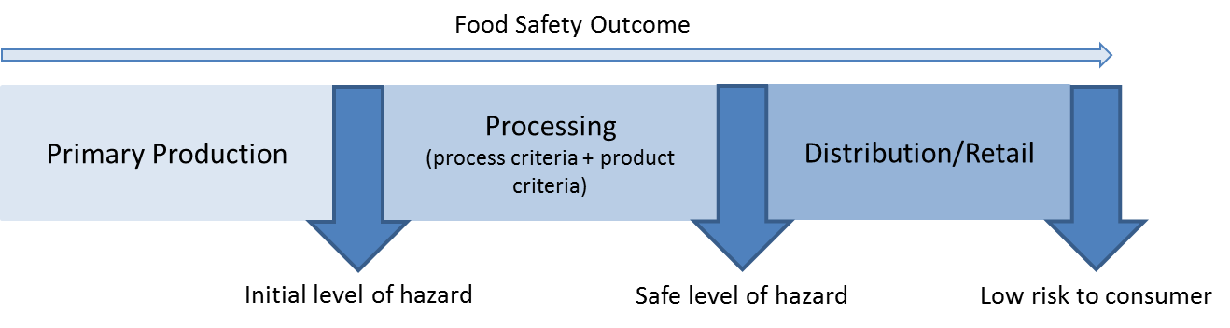
Standard 4.2.4 includes requirements for the production of raw milk products where it can be demonstrated that processing ensures that pathogenic microorganisms that may be present in the raw milk are reduced to safe levels. This is achieved through:

- Controls on production, collection and transport that ensure the initial level of an identified hazard in the raw milk at the start of processing will not impact on the safety of the final product.
- The intrinsic physico-chemical characteristics of the raw milk product do not support growth.
- Controls during processing that result in no net increase in hazard levels during manufacture.

3. VALIDATION REQUIREMENTS
Validation of the process criteria for a raw milk product must demonstrate that the combination of process steps used during manufacture reduces to safe levels any pathogens that may be present in the raw milk. For raw milk cheese the process steps should ensure there is no net increase of pathogens during processing and the cheese does not support their growth.

Conceptually the no net increase of hazards during processing can be written:

∑ Reduction + ∑ Increase ≤ 0
Where:
∑ Reduction = the total (cumulative) reduction of the hazard achieved by the process

∑ Increase = the total (cumulative) increase of the hazard supported by the process

Validation should take into account the initial level of the hazard; potential increases due to growth or entrapment of pathogens during curd formation; reductions during acidification and maturation/ripening, and the physico-chemical characteristics of the cheese.

Initial level of the hazard

The main source of the pathogen(s) of concern is the raw milk. The primary production control measures implemented for raw milk production, collection and transport determine the initial level of pathogens that may be present in the raw milk to be used for processing.
Microbiological analysis of the milk should verify that the primary production controls in place are effective in managing the potential for pathogen contamination and growth. Creation of a database to enable statistical analysis of analytical data may be beneficial to enable understanding of trends in prevalence and sources of contamination.

Increase

The validation process needs to account for all potential growth steps during processing. This involves understanding whether the characteristics of a product are static or vary over time. For example, many styles of cheese (eg. internal and surface mould ripened cheeses) experience large changes in their intrinsic characteristics during maturation, especially pH and water activity. Such changes may lead to conditions where pathogen growth is supported.

In cheese production, the potential for growth during the initial production phase will depend on the amount and duration of heat applied prior to the addition of starter culture and during the coagulation process (noting that the growth of the starter culture and production of lactic acid during this time will become inhibitory). Starter culture activity and the time it takes to achieve pH reduction must be known.

Reduction

The combination of hurdles applied during the production of a raw milk product contributes to the total cumulative reduction achieved by the process. Two major areas identified for the control of pathogens in raw milk cheese are during acidification and the maturation/ripening stage, during which time the intrinsic characteristics of the cheese come in to play. The raw milk product and manufacturing protocol needs to be well described and characterised as part of the validation process in order to identify the measures contributing to pathogen reduction and how they are achieved.

4. Pre-validation activities
The focus of pre-validation is to document and describe the raw milk product characteristics and processes that will be validated against. For cheese this includes clearly identifying the:

- cheese classification
- cheese production processes
- physico-chemical characteristics of the cheese
- maturation/ripening conditions to produce a cheese of the required characteristics

Cheese
Many different production methods exist for cheese manufacture, depending on the cheese style required. Addition of ripening cultures (internal and external) can radically influence the pH of the cheeses. Different salting methods such as direct addition to the curd (Cheddar), dry salting (blue cheeses) or the use of brine (feta), influence the salt content of cheeses but also the water activity. The action of bacteria, fungi and moulds on the breakdown of proteins (proteolysis) can influence both the pH and water activity. All of these factors need to be considered in the assessment of the raw milk cheese.

Describing and characterising a cheese is an important component of the validation process. This helps identify the key measures (processing factors and intrinsic characteristics) that need to be included. Five super families have been described to assist this process:

- Fresh
- Internal bacterially ripened
- Internal mould
- Surface mould
- Surface ripened

Each of these groups is based on characteristic ripening agents or manufacturing technology that gives a cheese its physico-chemical properties that influence potential growth, inactivation and/or survival of pathogenic microorganisms.

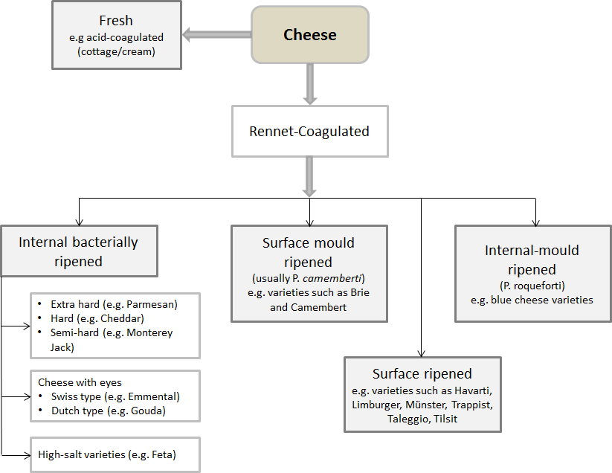

Figure 1. Simplified classification of cheese into five superfamily groups. Adapted from Fox et al (2000)

Information required:

- physical characteristics of the cheese (dimensions, shape etc.)
- cheese manufacturing process steps including time, temperature, pH, salt etc.
- data on source and amounts used of all ingredients (e.g. salt, rennet, lipases, calcium chloride, colours, surface washes etc.)
- data on key physico-chemical characteristics

Acidification
The initial fermentation of milk in the cheese making process is one of the key hurdles in limiting the growth of pathogenic microorganisms. As milk is warmed, starter cultures begin to metabolise sugars (e.g. lactose) to acids and other compounds.
During this process, the pH of the milk reduces from approximately 6.6 to less than 4.5 over time, approaching the minimum pH for growth for most pathogenic microorganisms. Prior to this point, pathogens have the potential to grow, at a rate dependant on the temperature profile of the curd.

Starter culture activity (the ability of starter cultures to produce lactic acid and drop milk pH) is an important consideration. Many factors act to influence the ability of lactic acid bacteria species to reach any specified pH/time target, including:

- temperature
- inoculum size
- metabolism

Acid production and the resultant decrease in pH affects the growth of many non-starter bacteria, including pathogens which may be present in the raw milk. Ensuring the production of acid at the appropriate rate and time is critical at this stage. Starter culture activity under the processing conditions to be used needs to be assessed. An earlier pH drop will limit the growth of any pathogens present.

Information needed:

- source and characteristics of starter and adjunct cultures
- preparation steps and inoculum size for starter and adjunct cultures

Intrinsic characteristics of the cheese (maturation/ripening)

Inhibition of microorganisms during ripening results from the combined effects of pH, decreased water activity (related to salt content), antagonistic flora and organic acids. The processing steps and criteria that provide for these intrinsic product characteristics must be well understood and these measures validated.

Parameters are not static and vary during the ripening period as moisture is lost, salt diffuses through the curd and other biochemical changes occur. Of the factors that influence microbial growth or survival, pH and water activity have been identified as the main parameters for determining whether growth or no growth (inhibition) will occur.

- pH
The pH of cheese curd after manufacture generally lies within the range 4.5-5.3. For mould and smear ripened cheeses, however, the pH can increase during ripening due to the growth of yeasts and moulds. For blue cheeses the pH may increase to 6.0-6.5 during ripening and storage (>90 days) while for surface ripened mould cheeses the pH can increase to around 7.0.

- water activity
Water activity (determined by factors including salt concentration), has a major effect on the growth of microorganisms in and on cheese. In general, the longer the ripening period the lower the moisture content of the cheese and the resultant water activity due to the salt content. The level of salt used depends on the variety and can vary from 0.7-7%.

For most cheese varieties salt is added after curd formation through brining or dry salting. While salt absorption into the cheese can occur fairly rapidly, salt diffusion in cheese moisture is a slower process. Depending on the variety it may take days or weeks to obtain salt in moisture equilibria throughout the cheese mass.
Information needed:

- time, temperature and humidity during cheese ripening
- data on physico-chemical characteristics of cheese, including changes over time.

5. Validating control measures
Based on the scientific assessment undertaken for raw milk products (Scientific information for the assessment of approved raw milk products - cheeses), the following validation procedure is recommended for raw milk cheeses (and outlined in the flow diagram at Figure 2).

Demonstrate that the physico-chemical characteristics of the cheese do not support the growth of identified pathogens:

While manufacturing protocols for dairy products other than cheese have not been assessed, there are a number of individual parameters that have been identified as preventing the growth of pathogens (Codex 2007):

- water activity below 0.92
- pH below 4.4
- combination of pH below 5 and water activity below 0.94

Dairy products with these individual intrinsic characteristics would not support the growth of pathogens. These are conservative limits and, as for cheese, combinations (e.g. pH and water activity) at lower/higher levels may also be inhibitory but would need to be validated.

A variety of approaches can be used to validate the manufacturing process and control measures to be used including:

- the use of approaches that have previously been approved
- the literature
- predictive modelling
- challenge studies.

An allowance of 0.5 log is included at box 3 of Figure 2 which is two times the estimated standard deviation associated with the experimental enumeration method (viable counting/plate counts.

Cheese characteristics may be able to be optimised to reduce the probability of pathogen growth. This could include adjustments to temperatures, time, salting (timing and concentration) and pH.

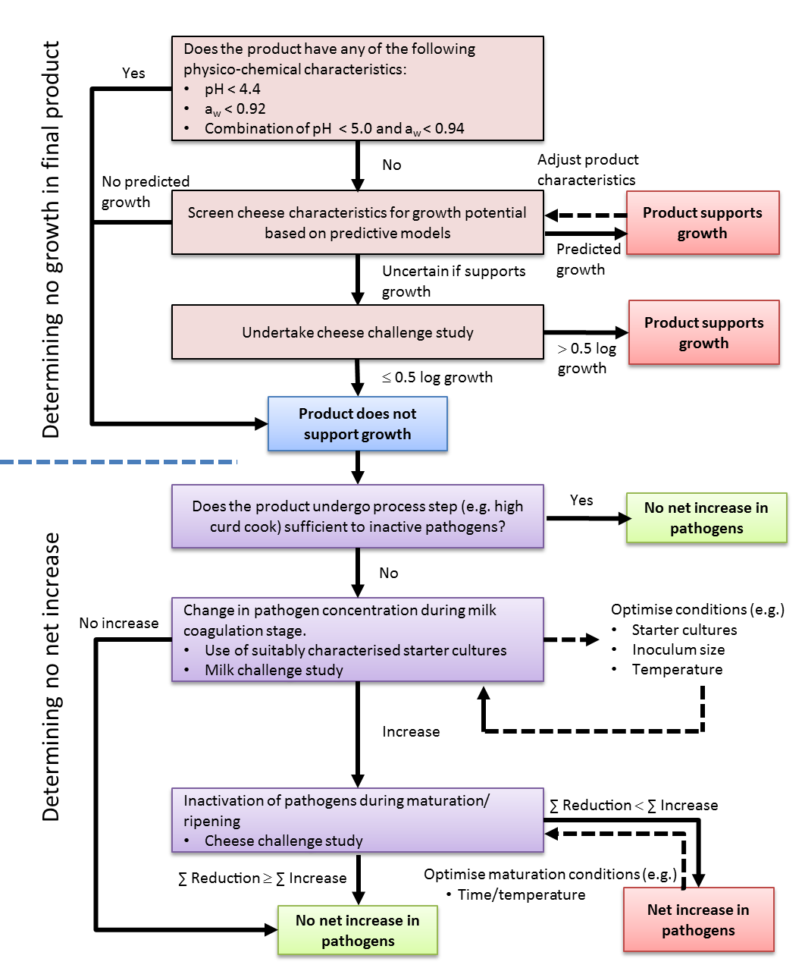
Figure 2 Flow diagram illustrating the determination of ‘no growth’ and ‘no net increase’ criteria.
Provide evidence that there is no net increase of pathogens during the processing steps:
- data on changes in concentration of identified pathogens during milk warming and acidification stages for the process steps identified for the product
Information required:

Examples of evidence may include:
- specified heat treatments that would inactivate pathogens
- milk fermentation challenge studies to screen starter cultures
that minimise growth of pathogens due to acidification. This may include quantification of the maximum acidification rate, and the time to reach the maximum acidification rate.

This information could be sourced from:
- predictive models
- relevant published challenge studies*
- specific milk challenge studies

∑ Reduction + ∑ Increase ≤ 0

- characterise inactivation of identified pathogens during maturation/ripening
Information required:

Evidence to demonstrate inactivation during cheese maturation/ ripening, for example:
- predictive models for inactivation kinetics
- published challenge studies*
- specific challenge studies for raw milk cheese

This can be optimised through adjustment of maturation/ripening conditions such as time, temperature.

- evidence that maturation/ripening time provides for no net growth, considering changes in pathogen growth (including concentration effect due to curd formation) and inactivation during cheese production and maturation
Information required:

- all evidence from challenge studies, scientific literature and validated predictive models are demonstrated to be relevant to the production and maturation/ripening of the raw milk cheese, including consideration of both variability and uncertainty.

* Published challenge studies are observational in nature and the applicability of the results need to be considered in context of the proposed raw milk cheese being assessed. For example, if another starter culture, higher inoculum size or temperature profile was used then the actual growth/inactivation could be different.
Scientific literature

Reference to published milk and cheese challenge studies may be useful in providing evidence on the factors that inhibit growth of pathogens during cheese production and maturation/ripening.
If referring to experimental evidence, there are some importance factors that should be considered, such as:

- the pathogens chosen
- the processing steps, including temperature and time, maturation/ripening conditions
- the method of inoculation e.g. prior to addition of starter culture or to commercial cheeses
- the use of raw milk or pasteurised milk for inoculation
- the analytical methods used to measure physico-chemical characteristics

Milk challenge studies are generally performed at constant temperature. Care is necessary to extrapolate these results to the dynamic temperature-pH-salt changes observed in cheese production.

Predictive modelling

Many models have been developed for predicting growth rates, probability of growth and survival of pathogens in food products, although not all have been validated in fermented dairy products.

FSANZ has illustrated the use predictive models to evaluate the growth of L. monocytogenes in cheese in the Scientific information for the assessment of approved raw milk products – cheeses document including

- the Dalgaard model (Mejlholm and Dalgaard, 2009; Mejlholm et al. 2010)
- the Augustin model (Augustin et al. 2005).

Predictive models that may have relevance for other pathogens in cheese can be found at Foodrisk.org, Combase (combase.cc), Sym’Previus (http://www.symprevius.net/index.php?vrs=sym_previus_predictive_microbiology) or the scientific literature. Factors that should be considered in the application of models to predict the behaviour of pathogens in cheese include the growth media and the range of environmental conditions of the experiments used to develop the model.
Insufficient data was available from challenge studies to evaluate the utility of the Dalgaard model, particularly due to the lack of evidence for lactic acid concentration.

In the Augustin et al. (2005) model, the water activity calculated using the salt-in-moisture phase concentration of the final cheese did not provide predictive accuracy. However, adjusting the water activity accounting for differences in proteolysis between cheese superfamilies suggested that it may have utility in predicting the probability of growth of L. monocytogenes in challenge study cheeses.

This model could be used as preliminary screening tool to formulate cheeses for the probability of growth of L. monocytogenes prior to the design of challenge studies.

For probability of growth models such as Augustin et al (2005), the following categories have been suggested:

- reliably predict no-growth (probability of growth < 0.1)
- reliable predict growth (p > 0.9)
- uncertain region where growth can’t be reliably predicted (0.1 ≤ p ≤ 0.9)

Challenge studies

Where the potential growth of pathogens using predictive models is uncertain, challenge studies should be undertaken.

The aim of a challenge study is to mimic as closely as possible the processes of contamination of the product, its processing, packaging, storage and distribution and end use, so as to evaluate the fate of pathogenic contaminants and consequent risk to public health.

Factors that can affect the fate (growth, inactivation, or survival) of the organism(s) of concern include (Ross, 2011):

- the physico-chemical properties of the food
- other micro-organisms in the food,
- the conditions (temperature, gaseous atmosphere, packaging type) under which the
- product is processed, distributed, stored and displayed and
- the properties of the organism(s) of concern (e.g. environmental limits to growth, responses to environmental conditions singly and in combination)

Material developed for the Ministry for Primary Industries, New Zealand titled Challenge testing of microbiological safety of raw milk cheeses: the challenge trial toolkit provides practical guidance on designing challenge studies (Ross, 2011). The key considerations when undertaking a challenge study include the following:

- the type of study (i.e. whether pathogen growth, or inactivation, or both are expected) so as to be able to correctly design the experiment to answer the specific question.
- the organism(s) of interest.
- factors related to the product of interest that will affect the fate of the challenge organism, including product preparation (process steps particularly Critical Control Points), variability in product and process characteristics, and types of packaging. The presence of competitive flora.
- the natural mode(s) of contamination of the product (e.g. stage of processing, how transferred), including:

  - levels of the organism(s) of interest that could be encountered in the food in “real world” situations
  - the physiological state of natural contaminants (e.g. whether stationary or exponential phase, spores or vegetative cells, etc.),

- storage duration and conditions (e.g. temperature, packaging type),
- variability (e.g. in pathogen response, in product or process characteristics, storage duration and conditions, etc. and including potential for product mishandling by others in the chain)
- number of samples and frequency of sampling.
- sampling method and analytical methods.

Details on each of these considerations are provided in the guidance document. Additional information on performing challenge studies for growth potential and durability studies can be found in Beaufort (2011) and European Union Reference Laboratory (EU-RL) for Listeria monocytogenes (2009).

References
Augustin, J-.C., Zuliani, V., Cornu, M. and Guillier, L. (2005) Growth rate and growth probability of Listeria monocytogenes in dairy, meat and seafood products in suboptimal conditions. J. Appl. Microbiol. 99:1019-1042.
Beaufort A (2011) The determination of ready-to-eat foods into Listeria monocytogenes growth and no growth categories by challenge tests. Food Control 22:1498-1502
Codex (2007) Guidelines on the application of general principles of food hygiene to the control of Listeria monocytogenes in foods. CAC/GL 61 - 2007
Codex (2008) Guideline for the Validation of Food Safety Control Measures (CAC/GL 69 – 2008). http://www.codexalimentarius.org/download/standards/11022/cxg_069e.pdf Accessed 15 July 2013
European Union Reference Laboratory (EU-RL) for Listeria monocytogenes (2009) Technical guidance document - On shelf-life studies for Listeria monocytogenes in ready-to-eat foods. Version 2 14/11/2008 correction 29/04/2009 http://www.ansespro.fr/eurl-listeria/Documents/LIS-Cr-200904G.pdf
Accessed 25 October 2013
Fox, P.F., Guinee, T.P., Cogan, T.M. and McSweeney, P.L.H. (2000) Fundamentals of Cheese Science. Aspen Publishers.

FSANZ (2009) SD3 - Microbiological Risk Assessment of Raw Milk Cheese http://www.foodstandards.gov.au/code/proposals/documents/P1007%20PPPS%20for%20raw%20milk%201AR%20SD3%20Cheese%20Risk%20Assessment.pdf
FSANZ (2013) Agents of Foodborne Illness. 2nd ed, Food Standards Australia New Zealand, Canberra. http://www.foodstandards.gov.au/publications/Pages/agentsoffoodborneill5155.aspx
ICMSF (2008) Microorganisms in Foods 8: Use of Data for Assessing Process Control and Product Acceptance. Springer. New York, US.
Mejlholm, O. and Dalgaard, P. (2009) Development and validation of an extensive growth and growth boundary model for Listeria monocytogenes in lightly preserved and ready-to-eat shrimp. J. Food Protect. 72:2132–2143.
Mejlholm, O., Gunvig, A., Borggaard, C., Blom-Hanssen, J., Mellefont, L., Ross, T., Leroi, F., Else, T., Visser, D. & Dalgaard, P. (2010) Predicting growth rates and growth boundary of Listeria monocytogenes — An international validation study with focus on processed and ready-to-eat meat and seafood. Int. J. Food Microbiol. 141:137—150
Ross T (2011) Challenge Testing of Microbiological Safety of Raw Milk Cheeses: The Challenge Trial Toolkit. MAF Technical Paper No: 2011/51. New Zealand Ministry of Agriculutre and Forestry. http://www.foodsafety.govt.nz/elibrary/industry/challenge-trial-toolkit/. Accessed 27 July 2012

